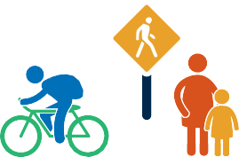
Safer Roads Ahead

Local Road SAFETY Plan

[AGENCY NAME]

Kick-off Meeting
Date and Time: [INSERT DATE AND TIME]
Location: [INSERT MEETING LOCATION & ADDRESS]
- Welcome remarks by LRSP Coordinator or Champion
- Introductions
- What is a Local Road Safety Plan – Presentation outlining what a Local Road Safety Plan is and how developing one can benefit [INSERT AGENCY NAME].
- Identify other agencies or individuals who should be invited to join the working group.
- Summarize Data Analysis – An initial data analysis has been conducted prior to this meeting to provide the group with background information on a variety of potential safety issues in [INSERT AGENCY NAME].
- Begin Identifying Emphasis Areas for the Plan
  - Education
  - Enforcement
  - Engineering
  - Emergency Services
- Next Meeting – Schedule a date for a follow-up meeting
Meeting Contact: [INSERT PHONE NUMBER & EMAIL FOR MEETING ORGANIZER]

